# Analysis of Transcripts

## Structure of the transcripts

All students seem to use context view, information view, and functional view. Is this something they learned as part of the course?

## Type of arguments used

Often when a statement is attacked this leads to a discussion. Then the outcome can be three things:

1. The original statement is defended and remains valid.
2. The original statement is refined. The original statement becomes invalid and the refined version is valid.
3. The original statement is defeated and becomes invalid.

Therefore, it seems that our critical questions should allow for the possibility to *refine* elements or relations. So when you question an element or a relation, you attack it on a specific part.

**Example 1. "Actor *student* has action *create a car"***

This can be attacked in the following ways:

* + Change Actor: *Create a car* is an action of another actor
  + Rename Action: *Create a car* is not the correct name.
  + Remove Action: *Create a car* is not an action --> Remove action

But it can also be refined:

* + Refine action: *Create a car* is composed of other actions.

So when one attacks, one can either choose to remove the element all together, or to change it contents. Moreover, one can choose to refine instead of attacking as well.

**Example 2. "Action *use simulation* contributes positively to goal *understand queuing theory better*"**

This can be attacked in multiple ways:

* + Change relationship: The action does not contribute positively to the goal
  + Remove relationship: There is no relationship between the action and the goal

Sometimes an argument is about several elements. For instance:

**Example 3. "Actor *student* and actor *professor* can be clustered together"**

I am not sure if we should take this into account as well. It would create more complexity and I wouldn't know how to implement it exactly.

There are also trade off arguments.

**Example 4. "If the traffic simulation system has an option to create assignments, this allows the professor to test students. However, then the system will be more complex"**

So in GRL this would look something like this:

hurt (-)

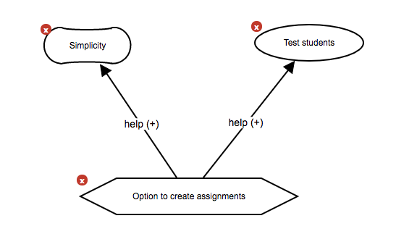

Then someone may give a counter argument stating that *"Test students" is not a goal of the system.*

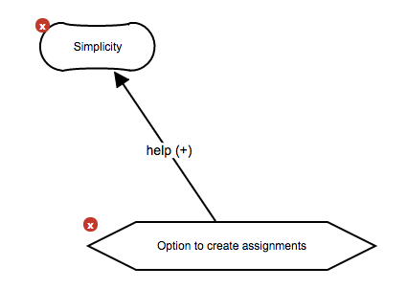

hurt (-)